Assignment 1

Digital Business Analysis and Design

INF20029

Student Name: Nguyen Nam Tung

Student ID: 103181157

Lab: Thursday 16:30 – 18:30

# Part A

1. A stakeholder is a person or an organization with an interest in the decisions and activities of a business. The main AVTS stakeholders may include:

* College students, who are the primary customers of the AVTS booking system and are searching for cheap and appealing spring break vacation packages. Therefore, the aspects of the AVTS booking system in which they are interested are resorts information such as availability, price, and the interesting features of the resorts.
* Resorts that have contracted with AVTS to offer rooms to college students. They are interested in the number of bookings per week, room types and price, as well as the payments from AVTS and the ability to report the damages caused by spring breakers during their stay.
* Employees of AVTS who are responsible for managing the reservation system, updating resort information, and providing customer service to users in order to ensure the system's smooth operation. The aspect of the AVTS booking system that is the particular interest of is the simplicity and convenience of the use and maintenance of the booking system, allowing them to easily communicate with the customers.
* AVTS shareholders and investors who fund the company and seek to maximise its profits. They are interested in the number of reservations, the revenue, the effectiveness, and the growth and expansion potential of the AVTS booking service.
* Payment processor who handles financial transactions and ensures their security and timeliness. Aspects of AVTS that are of particular interest to them include detailed booking information, such as the price of the rooms, the number of bookings, the customers' payment information, date of the transaction and booking.
* Insurance companies that provide coverage for damages caused by spring breakers. They must ensure that they have sufficient funds to cover the damage caused by the spring breakers and that payments are made to the correct individuals. As a result, the aspect that they need in the AVTS booking system is detailed information about the damages as well as the resort's payment details to obtain the insurance.

1. Functional requirements specify what the system must be able to do to accomplish a desired output. As the lead analyst of AVTS, the following methods can be used to gather information about the functional requirements for the social networking subsystem:

* Surveys: Survey is the technique of gathering information from a representative sample of individuals. With regard to the AVTS service, online survey is the most suitable with some questions such as:
  + What kind of social networking features would you like to see on AVTS's platform?
  + How often do you use social media? What are the features that make it more engaging?
  + How likely are you to use social networking features on the AVTS platform?
* Focus Group: Focus group is another method of gathering information by having a group of people sit together and be asked about their opinion on a topic. Some questions for the focus group can be:
  + What types of information do you think would be useful to share with other students on the AVTS platform?
  + What concerns do you have about using social networking features on the AVTS platform?
  + Do you think that social networking is an important part of AVTS system?
* Interviews: Interview is a conversation among individuals. One person asks a question and the other responds. Some potential questions for the interviews can be:
  + How often do you use social media to connect with other students planning spring break trips?
  + What are the weaknesses and drawbacks of utilizing this feature?
  + Would you like to add any new elements to the networking system of AVTS?
  + Will you recommend this system to the other users and why?
  + Do you want to share your trip information to other people?

All of the following techniques can be used for people who have used the AVTS system in the past and who intend to use AVTS in the future. By doing so, the quality and the efficiency of this social networking feature can be significantly enhanced because it will focus exactly on what the stakeholders want and avoid applying the features that they find redundant.

1. The main functional requirements for each major subsystem area are illustrated as follows:

* Resort relation subsystem
  + Resort information management: The subsystem should provide a platform for resorts to enter and update information about their facilities, pricing, and available room types.
  + Viewing booking: The resorts should be able to view their weekly reservations.
  + Reporting damages: The system should enable resorts to report and collect payment for damages caused by spring breakers during their stay.
  + Communication with resorts: The system should be able to communicate with resorts regarding booking status, payment issues, and other concerns.
* Student booking subsystem
  + Registering and signing up booking accounts: The subsystem should enable the student to sign up and register a booking account to keep track of their reservation records.
  + Searching and viewing resort information: The students can search and view resort information, including prices, room types, and special features.
  + Viewing and comparing resorts: The students can view and compare resort options based on criteria such as price, location, facilities, and reviews/ratings.
  + Booking and payment: The system must allow the students to enter contract information, book rooms, pay deposits and make payments online.
  + Cancellation and refunds: The subsystem must have the ability to handle booking cancellations and refunds.
* Accounting and Finance subsystem
  + Payment management: The system must maintain and track accurate records of payments made to resorts and payments received from students.
  + Invoices management: The system must generate invoices and payment reminders for students who have not made their final payment.
  + Financial reporting: The system can provide reports on revenue and expenses.
  + Refund management: The system should be able to handle refund requests and process refunds efficiently.
* Social networking subsystem
  + Registering and signing up account: The users must be able to create and manage user profiles and accounts.
  + Posting and sharing content: The system must allow users to post updates, and share photos and videos.
  + Searching: Students must be able to search for other users, content, and groups based on specific keywords and criteria.
  + Messaging and chat functionality: The system must have chat features that allow communication among the students.
  + User feedbacks and reviews: The system should allow users to leave feedback and reviews of resorts, destinations, and other aspects of their spring break experience.

1. AVTS should implement a range of security measures to protect the system and its users from potential security threats. This will help to build trust with users, reduce the risk of security breaches, and safeguard the reputation of the business. Some security requirements for AVTS could include:

* User Authentication and Authorization: AVTS should require users to authenticate themselves with strong passwords and implement appropriate authorization mechanisms to ensure that only authorized users can access sensitive information. One of the most popular authorizations feature that AVTS can use is using phone number and email verification.
* Data Encryption: Sensitive data (such as credit card numbers and personal information) must be encrypted to prevent hackers from gaining access to the information.
* Data Recovery: Critical data should be backed up and can be recovered in case of a system failure.

Regarding the ability of students from other regions to reserve rooms via AVTS system, there should be no technical restrictions as long as they have access to internet and can pay through the system. However, there might be issues with laws and regulations in different countries that may arise, including data protection laws, taxation policies and consumers protection laws. AVTS must assure the compliance with those regulations. In addition, the AVTS system must support multiple languages to accommodate non-English speakers, as well as having the ability to handle multiple currencies for payments and refunds of international users. Last but not least, AVTS would also need to be aware of the cultural differences between various nations in order to avoid misunderstandings and conflicts. By addressing these potential issues, AVTS can be more accessible to customers all around the world, thus improving the number of bookings of the website.

1. Non-functional requirements focus on how well the system operates. AVTS can have some non-functional requirements such as:
   1. Performance: The system should be able to support a large number of users at the same time and provide a fast and responsive user experience.
   2. Reliability: The system should have a minimum delay and disruptions.
   3. Scalability: The system should be able to handle an increase in the number of users without degrading the performance of the system.
   4. Usability: The system should be user-friendly and easy to navigate, with clear and precise instructions and error messages.
   5. Availability: The system should be highly available, minimizing downtime to provide uninterrupted services to users.
   6. Compatibility: The system should be compatible with different browsers, devices, platforms to help more users have access to the system
   7. Maintainability: The system should be easy to maintain, modify and update.
   8. Security: The system should be secure and protect user data from security threats.
   9. Integration: The system can integrate with external systems and services, such as payment processors and social media platforms like Facebook, Instagram.
2. In these modern days and ages, technological devices and features are utilised by a large number of individuals all over the world. These technologies offer numerous advantages, and the AVTS booking system can utilise some of them to boost system performance. Mobile application is one of the technological trends that AVTS can utilise. According to a study conducted by Josh Howarth, 92.3% of internet users access the internet using smartphones (Howarth, 2023). This means that AVTS should consider developing a mobile app that students can download onto their smartphones in order to reach more smartphone users who wish to book online service and to help them easily have access to the booking system, resort information, and other travel-related details. This will increase the system's accessibility, make it easier for students to make reservations and thus increase the number of bookings in the system. Additionally, Virtual Reality (VR) is another useful tool for enhancing the experiences of students. In the tourism industry, virtual reality has proven to be highly successful. A vivid illustration for this is Thomas Cook Airline. Thomas Cook Airline provides helicopter flights over New York City. Due to a decline in the reservation numbers, the company decided to work with a virtual reality studio and developed a VR tour using recordings from the helicopter flights. As a result, the company’s reservation increases by 180% because Virtual Reality helped it stand out from the competition by delivering unique experiences to tourists (Izchak, 2022). Therefore, in order to improve the pre-trip experience for students, AVTS could incorporate virtual reality (VR) technology that provides students with virtual tours of the rooms, the resorts’ facilities and their surroundings. This will enhance their booking experience by providing them with a greater understanding of what to expect when they arrive at the resort. This feature can assist AVTS in attracting more customers and enhancing its brand image by providing students with unforgettable experiences, giving the company a competitive advantage. Last but not least, Artificial Intelligence (AI) can also be utilised. In the travel industry, AI chatbots are becoming popular, and it is believed that they provide numerous benefits to the company. Skyscanner, a well-known travel booking company, uses chatbots on Messenger to assist customers with flight booking, flight status alerts, and trip-related queries. (Izchak, 2021). By implementing an AI chatbot, AVTS can provide 24/7 customer support, answer frequently asked questions, and help users navigate the resorts booking process more efficiently. This will reduce the workload of customer support teams and make it easier for students to get quick responds to their questions, thus greatly increasing customer satisfaction.

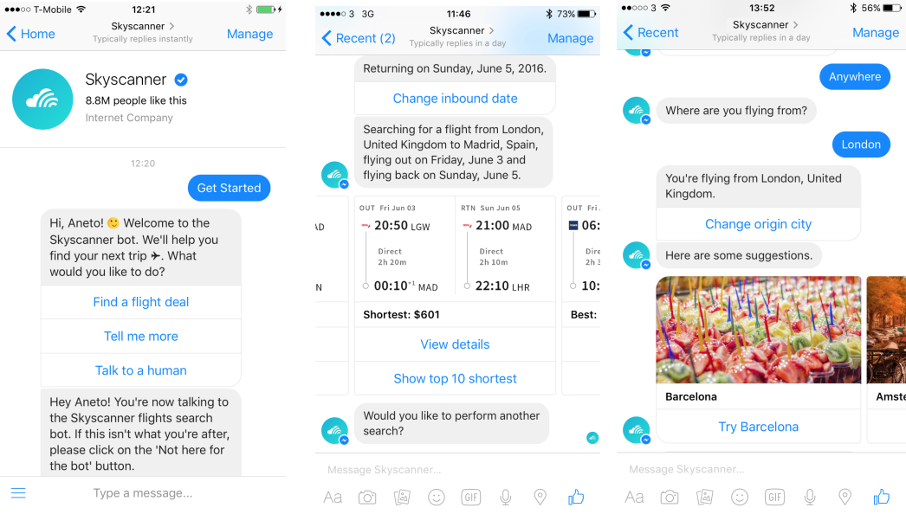

Figure 1: Skyscanner Messenger Chatbot

# Part B

1.

|  |  |  |
| --- | --- | --- |
| **Event** | **Type of event** | **Use case** |
| System opens for new bookings | Temporal event | Open booking system |
| Students browse resorts and do planning | External event | Browse resort |
| Students book a trip | External event | Book trip |
| Students are added or removed from the group | External event | Update group members |
| Students change the room type | External event | Update room type |
| System sends out final payment notices | Temporal event | Send final payment notices |
| Students cancel booking | External event | Cancel booking |
| Students pay their final bills | External event | Pay final bills |
| Student views booking status and resort details | External event | View booking status and resort details |
| Student checks in at resort | External event | Check in |
| Student checks out from resort | External event | Check out |

2.

By applying the user goal technique in AVTS Social Networking subsystem, different use cases of the AVTS users can be identified. As a result, this allows AVTS to develop a system that enhances the user experience and provides valuable features for students, ultimately increasing bookings and customer satisfaction. We have two users for this subsystem:

- College students who want to make new friends and share their trip experiences

- Resorts that want to attract, engage with more students to promote the resorts

As a result, we can identify the following use cases and use case diagram:

|  |  |
| --- | --- |
| **User** | **Use case** |
| College students | - Register social networking account  - Login to account  - Edit the user profile  - Send friend request  - Chat with friends  - Create group chats for students in the same resort or share the same interest  - Join group chats  - Post travel status  - Upload photos, videos  - Mention a resort/place in a post  - Tag a friend in a post  - Like and comment on travel status  - Share travel plan  - Share live location  - Create a memory footage after a trip  - Rate and review a resort  - Recommend a resort to a friend  - Log out the account |
| Resorts | - Create a social networking account  - Login to the account  - Edit resort’s profile  - Post the resort ‘s status  - Upload videos and photos  - Create events for students  - Comment on the students ‘reviews  - Log out the account |

Figure 2: Use case diagram

3. Here is the related context diagram:

Figure 3: Context diagram

4.

Figure 4: DFD Fragments

5.

|  |  |  |
| --- | --- | --- |
| **Class** | **Type** | **Attributes** |
| Traveller | Strong entity | - TravellerID (PK)  - Name  - Username  - Age  - Email |
| Room | Strong entity | - RoomID (PK)  - RoomType  - Capacity  - ResortID (FK) |
| Resort | Strong entity | - ResortID (PK)  - ResortName  - Location  - SpecialFeatures |
| Location | Strong entity | - LocationID (PK)  - LocationName  - Description  - ResortID (FK) |
| Party | Strong entity | - PartyID (PK)  - PartyName  - PartyDate  - LocationID (FK) |
| Interest | Strong entity | - InterestID (PK)  - InterestName |
| Traveller/Interest | Weak entity | - TravellerID (PK, FK)  - InterestID (PK, FK)  - LevelOfInterest |
| StayingRecord | Weak entity | - TravellerID (PK, FK)  - RoomID (PK, FK)  - CheckInDate (PK)  - CheckOutDate |
| LocationRating | Weak entity | - TravellerID (PK, FK)  - LocationID (PK, FK)  - RatingDate (PK)  - RatingStatus  - Note |
| PartyParticipation | Weak entity | - TravellerID (PK, FK)  - PartyID (PK, FK)  - ParticipationDate (PK)  - Role |

**Note:**

PK: Primary key

FK: Foreign key

Figure 5: ERD diagram

# References

Howarth, J. (2023). *Internet Traffic from Mobile Devices (Apr 2023)*. https://explodingtopics.com/blog/mobile-internet-traffic

Izchak, O. (2021). *6 Examples of How AI is Used in the Travel Industry* https://www.hotelmize.com/blog/6-examples-of-how-ai-is-used-in-the-travel-industry/#:~:text=AI%20Assistants%20For%20Travel%20Booking,accommodations%20and%20hire%20vehicles%20online.

Izchak, O. (2022). *4 Well-Thought Examples of Virtual Reality in Tourism*. https://www.hotelmize.com/blog/4-well-thought-examples-of-virtual-reality-in-tourism/#:~:text=Because%20tourism%20primarily%20uses%20VR,decision-making%20process%20for%20travelers.